## OpenClinica

Demo date: Aug 7, 2024  
Scoping start date: Aug 9, 2024

MSA Signature Date: Aug 22, 2024  
Onboarding Kick Off Date: Aug 26, 2024

Go Live Date: Sep 23, 2024

GTM POC: Ben  
Implementation POC: Arjun

ERP: QBO

Tax Integration: No Tax

### 

### Key people at Merchant

### Accountant: [Joe Gilmore](mailto:jgilmore@openclinica.com) - our main POC and super great to work with

* Elisia: Intern that will be helping Joe pull documents, etc, for the transition

### COO: Ben Baumann - likely not involved in the implementation process, but cares deeply about the quality of the switch from Maxio

### 

| AE/ Implementation Notes Sections [Ops International Team to Ignore]   * Info on how merchant bills   + Are there unique things about the customer creation process for this merchant?     1. Customer has a late fee that needs to be applied to either a) a new invoice, or b) the next invoice sent   + Information on how merchant bills     1. Merchant bills for multiple skus as well as blocks of consulting hours that are typically drawn down from, and expire after a certain period of time     2. Most customer’s contracts auto-renew   + How contract is broken up     1. Order forms are fairly straightforward with Skus at the front. There is also a MSA that stipulates renewal terms   + One off things to know about the merchant     1. Switch from Maxio is super important - see the [OpenClinica Checklist for Tabs.xlsx](https://docs.google.com/spreadsheets/d/1m2vx9Talj9rVEba9I39juljFe7-LpTYo/edit?gid=408985659#gid=408985659) * Is there any important merchant relationship information?  Accountant: [Joe Gilmore](mailto:jgilmore@openclinica.com) - our main POC and super great to work with  * + Elisia: Intern that will be helping Joe pull documents, etc, for the transition  COO: Ben Baumann - likely not involved in the implementation process, but cares deeply about the quality of the switch from Maxio 1) What is the merchant temperament? - very excited to switch to Tabs  2) Is there a key POC: (i.e.: who is the buyer/decision maker?) - Joe 3) What are the Tabs features that the key POC cares about? - renewals, and cash forecasting, easy collaboration with CS team for renewals |
| --- |

### 

### Company summary

OpenClinica accelerates clinical trials by automating data acquisition through its software-as-a-service platform. Offering a secure bridge between healthcare and research, OpenClinica is trusted by the world’s foremost life science companies, academic institutions, and government entities and has been used in more than 10,000 studies involving over five million patients. OpenClinica is proud to support hundreds of small, midsize and large research organizations spanning biotech, pharma, medical device manufacturing and contract research organizations.

Goals (North star)

What is the merchant's goal? What pain are we solving? Why are they buying Tabs?

OpenClinica are on Maxio today (have been with them since 2016), and are hugely frustrated with them. They want to replace Maxio with a much easier to use and automated system that still meets parity with Maxio features.

`Some of their biggest pain points:

* Renewals and contract terms and assumptions are frustrating
* Maxio/SFDC sync is frustrating - Joe has to go back and adjust things in SFDC frequently when they come to Maxio
* Had too many team members with access to Maxio and got dinged in their audit because of the risk there (our integrations to slack, etc, will be super helpful here)
* When he gets paid, he has to manually record payment in QBO and push sync to Maxio
* Reporting has been a pain in Maxio

Is there an opt out clause? If so, what is the merchant looking for so they do not exercise it?

No, however they did put together a very important checklist with the features important to them for this switch (essentially making sure we are at least on parity with Maxio)

[OpenClinica Checklist for Tabs.xlsx](https://docs.google.com/spreadsheets/d/1m2vx9Talj9rVEba9I39juljFe7-LpTYo/edit?gid=408985659#gid=408985659)

### Billing model

* Are there unique things about the customer creation process for this merchant?
  + Customer has a late fee that needs to be applied to either a) a new invoice, or b) the next invoice sent
* Information on how merchant bills
  + Merchant bills for multiple skus as well as blocks of consulting hours that are typically drawn down from, and expire after a certain period of time
  + Most customer’s contracts auto-renew
* How contract is broken up
  + Order forms are fairly straightforward with Skus at the front. There is also a MSA that stipulates renewal terms
* One off things to know about the merchant
  + Switch from Maxio is super important - see the [OpenClinica Checklist for Tabs.xlsx](https://docs.google.com/spreadsheets/d/1m2vx9Talj9rVEba9I39juljFe7-LpTYo/edit?gid=408985659#gid=408985659)

### Contract Processing Steps

1. Steps to process
   1. Contract PDFs are generally renewals or new orders.
   2. **Service Start Date:** use the Subscription Start Date at the top of the document. If not stated, the Start date should be the OC signature date  
       9/20/24 in the example below:

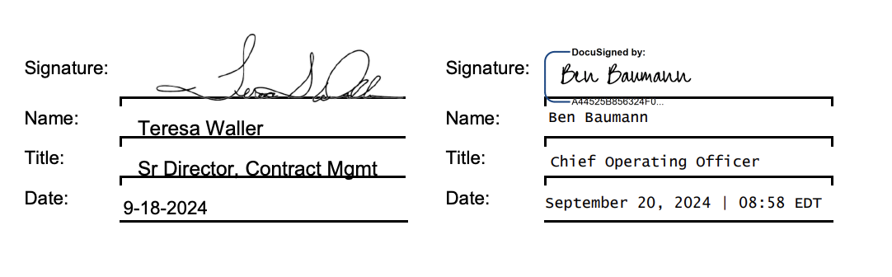

* 1. EXCEPTIONS!!:
     1. !! If there is no Subscription start date or signature available OR if the start date is based on a milestone event that we would not know, please use the Offer Expires date as a place holder AND make a note in this tracker: <https://docs.google.com/spreadsheets/d/1hRSvskDAUA316EfqqsVitL5PfsREJXLg/edit?gid=2025275138#gid=2025275138>
     2. After compiling this list, we’ll send to the Merchant to have them confirm missing info
  2. **Service Term:**
     1. For subscription products, follow contract language & use the term of the stated service period
        1. Generally one year
        2. Subscription products:
           1. DICOM
           2. OpenClinica - Academic Enterprise
           3. OpenClinica Core Platform
           4. OpenClinica eConsent
           5. OpenClinica Enterprise
           6. OpenClinica Insight
           7. OpenClinica Participate Subscription
           8. OpenClinica Randomize Sub
           9. OpenClinica Unite
           10. OpenClinica or BuildClinical Recruit

Rev rec straightline monthly based on the service term

Subscription revenue starts when the campaign begins

Billing starts 3 months ahead of service delivery

* + 1. For training and set-up products, revenue schedule should be set to 60 days after the bill date
       1. That is, if the Training SKU is invoiced on Jan 15, 2025, the revenue schedule should be March 15, 2025 – March 15, 2025
    2. For Consulting for ≤ 100 hours, service term is 6 months
    3. For Consulting for > 100 hours, service term is 12 months
  1. **Item Name:** The first column of each row is the name of the item
     1. It is also generally the name of the Integration Item
     2. Please search for the integration item - if the name is not in the drop down list, look at the small text below and see if that results in a better fit
        1. For example “Rackspace Server” is not an integration item but the small text in the same box says “Oracle-218871-RECURRINGCUSTOMSVC” which corresponds with the integration item “Recurring Custom Service”.   
           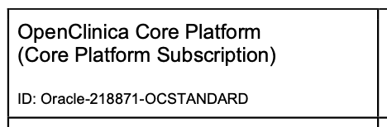
* **Integration Item and Rev Rec Category Mapping:**
  + Revenue Category Mapping (based on the table below):
  + If the item name does not match anything in the first column, set its revenue category to uncategorized. Column 2 is to map the Rev Rec Category ONLY
  + Integration Item mapping is column 3 (please also reference item name section below this table)

| **item_name_from_maxio** | **rev_category_in_tabs** | **integration_item_in_qbo** |
| --- | --- | --- |
| Community Edition Migration | Service | Service |
| Consulting (Fixed Fee) | Consulting | Service |
| Consulting Hours (T&M) | Consulting | Service |
| Consulting Hours Block | Consulting | Service |
| DICOM | DICOM | DICOM |
| Insight Training (Web Based) | Training | Service |
| OpenClinica - Academic Enterprise | A Enterprise | OpenClinica - Academic Enterprise |
| OpenClinica Core Platform | Core | Core |
| OpenClinica eConsent | eConsent | eConsent |
| OpenClinica Enterprise | Enterprise | Enterprise |
| OpenClinica Insight | Insight | Insight |
| OpenClinica Participate Subscription | Participate | Participate |
| OpenClinica Randomize Sub | Randomize | Randomize |
| OpenClinica Unite | Unite | Unite |
| OpenClinica Recruit  BuildClinical Recruit  All BuildClinical Products | Recruit | OpenClinica Recruit |
| Set-up - OpenClinica Randomize | Service | Service |
| Site Training (web-based) | Training | Service |
| Super User Training (in-person) | Training | Service |
| Super User Training (web-based) | Training | Service |
| **ALL OTHERS** | **Uncategorized** | **[leave blank]** |

If an integration item is not in the drop down list - please flag in this spreadsheet:

<https://docs.google.com/spreadsheets/d/1hRSvskDAUA316EfqqsVitL5PfsREJXLg/edit?gid=2025275138#gid=2025275138>

1. Billing Timing: Default to Bill in Advance, Due Start of Period unless stated otherwise in the contract
2. Net terms: Default to 30 if not stated in the contract
3. Billing Frequency:
   1. Use what is stated in the contract (Monthly, Quarterly, or Annual)
   2. If nothing is stated, default is Annually
   3. Sometimes the filename will say the frequency (e.g. “Abbott-218921 bill quarterly.pdf”), which overrides the default and the contents of the contract itself
      1. ^if you come across a contract like bullet point C - follow the instructions but please also flag in this spreadsheet

<https://docs.google.com/spreadsheets/d/1hRSvskDAUA316EfqqsVitL5PfsREJXLg/edit?gid=2025275138#gid=2025275138>

1. How do we handle taxes as a line item?
   1. No taxes
2. If contract is a PO, add PO # to invoices accordingly
3. Anything to ignore in contracts?  
   Ignore any discounts. Only show the post-discount amounts. For example, in the screenshot below, the billing term should be created as qty=100, unit price = $195.50, total price = $19,550.  
   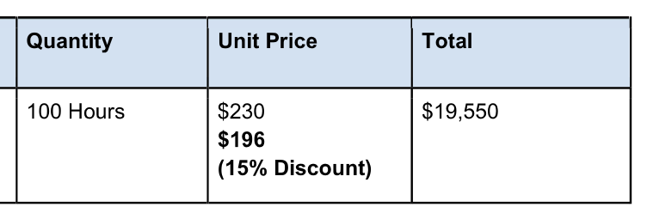

Ignore any late fees - do not create a BT for this.

1. Additionally, OpenClinica will now start selling the same product as BuildClinical. These should be processed under OpenClinica, but processing guidelines should be followed based on [BuildClinical guidelines](https://docs.google.com/document/d/1e7EyttTqONvjOsTYO2G44cuz1CgLOFthxEGthJdv_4s/edit?tab=t.0#heading=h.kpy0upq2lmk1) for these types of contracts.
2. Specifics processing things the merchant has requested that may differ by contract (e.g. always back-date invoice date to final day of the month)   
     
   Revenue schedule for Training should be set to 60 days after the bill date. That is, if the Training SKU is invoiced on Jan 15, 2025, the revenue schedule should be March 15, 2025 – March 15, 2025. This is a new request as of March 20, 2025.

### Events / Usage Processing (if necessary)

* No events / usage

Integration Items Processing (if necessary)

* All integration items match the names of the products (3rd column).
* All revenue schedule names also match the names of the products (2nd column).

| **item_name_from_maxio** | **rev_category_in_tabs** | **integration_item_in_qbo** |
| --- | --- | --- |
| Community Edition Migration | Service | Service |
| Consulting (Fixed Fee) | Consulting | Service |
| Consulting Hours (T&M) | Consulting | Service |
| Consulting Hours Block | Consulting | Service |
| DICOM | DICOM | DICOM |
| Insight Training (Web Based) | Training | Service |
| OpenClinica - Academic Enterprise | A Enterprise | OpenClinica - Academic Enterprise |
| OpenClinica Core Platform | Core | Core |
| OpenClinica eConsent | eConsent | eConsent |
| OpenClinica Enterprise | Enterprise | Enterprise |
| OpenClinica Insight | Insight | Insight |
| OpenClinica Participate Subscription | Participate | Participate |
| OpenClinica Randomize Sub | Randomize | Randomize |
| OpenClinica Unite | Unite | Unite |
| OpenClinica Recruit  BuildClinical Recruit  All BuildClinical Products | Recruit | OpenClinica Recruit |
| Set-up - OpenClinica Randomize | Service | Service |
| Site Training (web-based) | Training | Service |
| Super User Training (in-person) | Training | Service |
| Super User Training (web-based) | Training | Service |
| **ALL OTHERS** | **Uncategorized** | **[leave blank]** |

Post Processing Communications (if necessary)

### Customer Information

None

### 

### Rewatch Calls

* Ben and Joe reconnect after initial chats in May standard demo - <https://tabs.rewatch.com/video/k5zov4glmu9rcwh8-hold-joe-ben-reconnect-august-7-2024>
* Ben + Joe do custom demo - <https://tabs.rewatch.com/video/4pk8ppheluylryii-tabs-openclinica-august-9-2024>
* Rebecca meets with Joe - <https://tabs.rewatch.com/video/71wn25ipt7gwxd67-tabs-openclinica-sync-on-maxio-switch-august-13-2024>
* Rebecca and Ali meet with Joe and COO Ben Baumann - <https://tabs.rewatch.com/video/zcd4f2jmcat3hyur-tabs-openclinica-review-august-16-2024>
* Rebecca, Ben and Arjun meet with Joe to scope their needs switching over from Maxio - <https://tabs.rewatch.com/video/olmtk1y3hlz557nb-openclinica-tabs-august-21-2024>
* Sync to discuss moving forward, and Joe’s needs around renewal data in Cash forecasting - <https://tabs.rewatch.com/video/tzhkwhkc39kp6gwt-joe-ben-rebecca-sync-august-22-2024>